Extra Credit Solutions

Part 1 Address

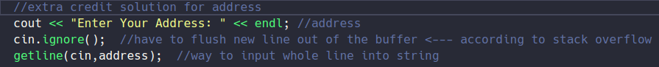

Part 2 Display decimal for Calculation 5 (shown here as cal6)

